Fred Smith (1944-2025)

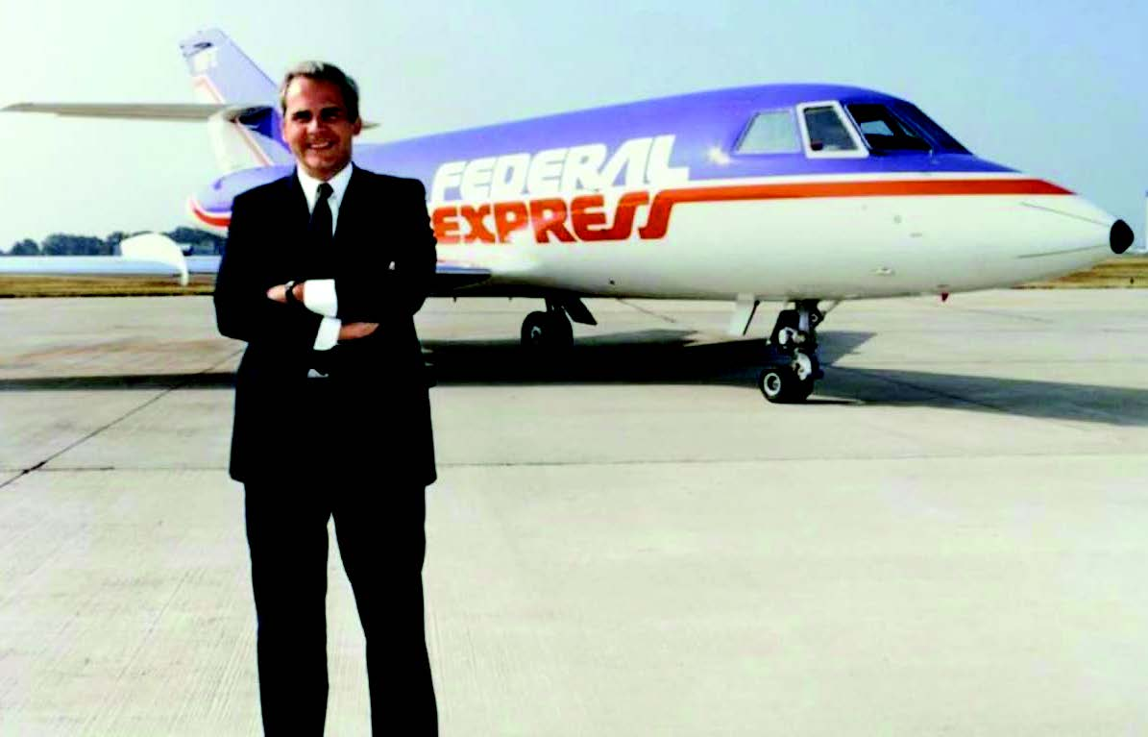
Wikipedia:
Fred Smith, is the founder, chairman, president, and CEO of FedEx, originally known as Federal Express, the first overnight express delivery company in the world, and the largest in the United States. . . . . In 1962, Smith entered Yale University. While attending Yale, he wrote a paper for an economics class, outlining overnight delivery service in a computer information age. . . . . After graduation, Smith joined in the U.S. Marine Corps, serving for four years, from 1966 to 1969, as a platoon leader and a forward air controller (FAC). . . . . As a Marine, Smith had the opportunity to observe the military's logistics system first hand.
Smith founded Federal Express in 1973 and began offering integrated air and ground delivery services to 25 cities. He used a fleet of 14 used Falcon 20 jets. His idea was to replicate in logistics the idea of a bank clearing house.
Quotes are of Fred Smith, reported in Neff & Citrin, Lessons from the Top.
From the company's inception, Smith held that "the information about a package was just as important as the package itself." This information not only helps companies track shipments, it helps companies manage and reduce inventories.
"Companies such as Wal-Mart, Dell, and FedEx are places where the velocity of business has been steadily increasing and people have gone to great lengths to take mass out. And the reason information is so important to us is because what we are really doing is providing fast cycle transportation and distribution, in lieu of inventory investment for our customers.
"The only reason a warehouse exists is that it's a place to put something so that you know gou've got it. It has no economic value in its own right. . . . We understood that if you could let everybody know exactly where their product was, people could begin to do away with this huge investment in warehouses. That is what FedEx does with its parcel tracking systems. At any given moment, it can tell you exactly where your package is. [This] allows our customers to keep near custodial control of the things in transit. They don't need to have inventory stuck someplace. Our trucks and planes are really 550-mile-per-hour warehouses."
"It is impossible to manage a business towards progressively higher levels of quality unless you actively measure the activities of the enterprise. That's been prove over and over again. And so, in addition to providing instantaneous accessibility to the customer, we also wanted the information to create a complete record of each transaction we handle, so we could use that mathematically to improve the quality of our business day after day.....”
"There are three measures we use to make sure we are going in the right direction. The Service Quality Index is the first one. The SQI is made up of 12 mathematically measured factors on every shipment.
Second is the CSI, that's the Customer Satisfaction Index, which is comprised of about 36 ratings customers give us on a repetitive basis. And the last one is our PQI, Process Quality Indicators, where individual operating monitor the sub-components that go into the service system. For example, the Los Angeles terminal will have PQIs on the 242 trucks coming into that terminal. And every day they'll want to have those 242 trucks be on time or early. They're constantly working on those PQIs because if the trucks are late, the containers don't get loaded. If the containers don't get loaded, then the last plane out doesn't get loaded, which causes our packages to be delayed.

